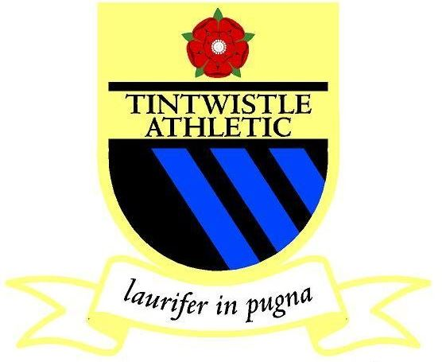
Tintwistle Athletic Privacy Notice
Tintwistle Athletic FC take your privacy very seriously. This Privacy Notice sets out how we use and look after the personal information we collect from you. We are the data controller, responsible for the processing of any personal data you give us. We take reasonable care to keep your information secure and to prevent any unauthorised access to or use of it.
What personal data we hold on you
You provide information about yourself when you register with the Club, and by filling in forms at an event or online, or by corresponding with us by phone, e-mail or otherwise.
The information you give us may include your name, date of birth, address, e-mail address, phone number, gender, and the contact details of a third party in the case of emergency. We may also ask for relevant health information, which is classed as special category personal data, for the purposes of your health, wellbeing, welfare and safeguarding. Where we hold this data it will be with the explicit consent of the participant or, if applicable, the participant’s parent or guardian.
Where we need to collect personal data to fulfil Club responsibilities and you do not provide that data, we may not be able honour or administer your membership.

Why we need your personal data
The reason we need participants’ and members’ personal data is to be able to run the football club and arrange matches; to administer memberships and provide the membership services you are signing up to when you register with the club. Our lawful basis for processing your personal data is that we have a contractual obligation to you as a participant or member to provide the services you are registering for.

Who we share your personal data with
When you become a member of the Club, your information, may be entered onto the Whole Game System database, which is administered by the FA. We also pass your information to the County FA and to leagues to register participants and the team for matches, tournaments or other events, and for affiliation purposes.
We may share your personal data with selected third parties, suppliers and sub-contractors such as referees, coaches or match organisers. Third-party service providers will only process your personal data for specified purposes and in accordance with our instructions.
We may disclose your personal information to third parties to comply with a legal obligation; or to protect the rights, property, or safety of our participants, members or affiliates, or others.

The name of the organisations we share your information with are as follow’s but not restricted to;
- FA Wholegame system
- Derbyshire FA
- East Manchester League
- Tameside League
- Stockport metro League
- High peak junior football league
- Manchester league
- Club Legends

Protection of your personal data
We have put in place appropriate security measures to prevent your personal data from being accidentally lost, used or accessed in an unauthorised way, altered or disclosed.

How long we hold your personal data
We keep personal data on our participants and members while they continue to be a member or are otherwise actively involved with the Club. We will delete this data up to two years after a participant or member has left or ended their membership or sooner if specifically requested and we are able to do so. We may need to retain some personal data for longer for legal or regulatory purposes. The personal data that is stored on Whole Game System is subject to their privacy policy and if you would like your personal data to be deleted from Whole Game System then please contact them.

Your rights regarding your personal data
As a data subject you may have the right at any time to request access to, rectification or erasure of your personal data; to restrict or object to certain kinds of processing of your personal data, including direct marketing; to the portability of your personal data and to complain to the UK’s data protection supervisory authority, the Information Commissioner’s Office about the processing of your personal data.
As a data subject you are not obliged to share your personal data with the Club. If you choose not to share your personal data with us we may not be able to register or administer your membership.
We may update this Privacy Notice from time to time and will inform you to any changes in how we handle your personal data.

If you have any questions about this Privacy Notice then please contact Jill Crossland.

